36.62: As shown below, a pair of slits whose width and separation are equal is the same as having a single slit, of twice the width.
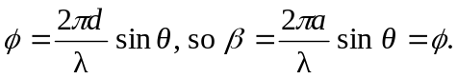
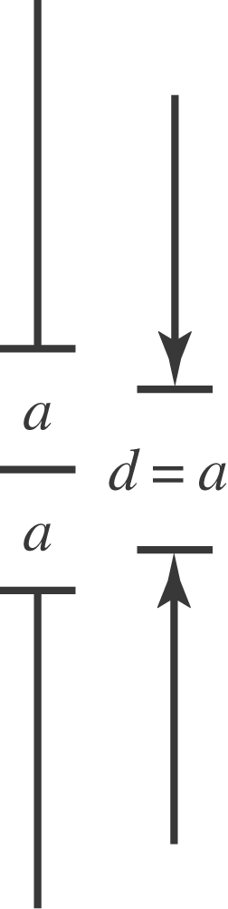

So then the intensity is
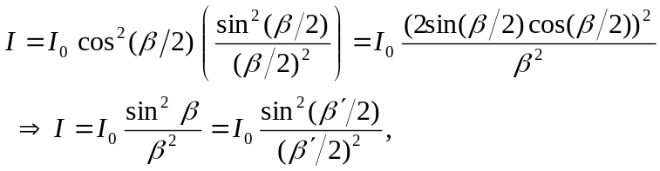
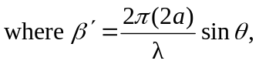 which is Eq. (35.5) with double the slit width.

